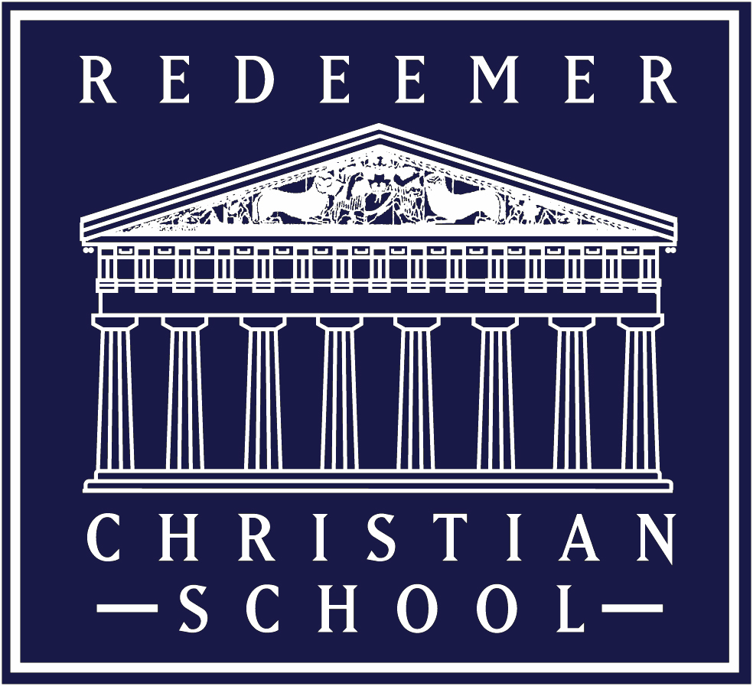

High School Class Supply List 2023-2024
Omnibus (History, Bible, Literature), Rhetoric, Spanish,
Protocol, Mathematics, Human Anatomy & Physiology, Electives

Writing Utensils
- Pens - Blue or Black (for daily, assignment, and tests)
- Pens - Red (for editing/grading)
- #2 Pencils (taking notes, drawing maps, diagrams, or in solving math problems)
- Erasers
- Highlighters for annotating text – Yellow, Pink, Green
- Colored Pencils (12 count) for maps/projects/diagrams/rendition drawings

Paper & Study Helps (Use College Ruled paper)
- Loose Leaf, Hole-punched, College Ruled Paper (place in your binder)
- Spiral Notebook; College Ruled
  - Science – 2 per year
- Sticky Notes and/or Repositionable Tabs/Flags for marking text
- 3 X 5 Index Cards
  - Science and Bible – 2 packages

Binders (Mark with your Name)
- 1.5” Binder (3 ring) – for Omnibus, Rhetoric, Spanish
- 1.5 “ Binder (3 ring) – Science
- (1) 8 packs of Dividers for Binder with Pockets
- Commonplace Book or Ruled Journal (Use a Composition Book – college ruled)

Miscellaneous
- Book Covers – 6 (required for use on textbooks)
- Organizational items for your lockers
- Backpack
- Zippered pencil bag for binder or pencil box (to hold pens, pencil, erasers, and other academic tools)

Student Uniform
Boys and Girls Everyday Uniform: Khaki or Navy Bottoms, Logo’d Polo Shirt in navy,
light blue, white, belt (boys), Closed-toe shoes/sneakers/athletic shoes

Dress Uniform for Chapel Days (Wednesdays): Boys-log’d French blue oxford, khaki pants, belt, dress shoes, navy tie; Girls—Light blue logo’d blouse, Two-pleat khaki skirt, dress shoes, navy tie. (May be ordered in the front office.)

Textbooks, Literature Books, and Consumable workbooks and logo’d polo are provided.

Electronic Devices: HS Students sometimes use electronic devices , i.e. iPad, tablet, or laptop, to access online assignments, papers, and research materials. MacBookPro laptops are provided. Students may NOT use phones for their lessons during class.

